--------------------------------------

RESULTS: MODEL 1 (STATS-ONLY BASELINE)

--------------------------------------

Average Accuracy: 0.58

Average F1-Score: 0.63

--------------------------------------

>> SUCCESS! The accuracy is low, proving that context alone is not enough.

output_file = "transformed_cricket_shots.csv"
This is the excel used to run the model against which gave low accuracy.

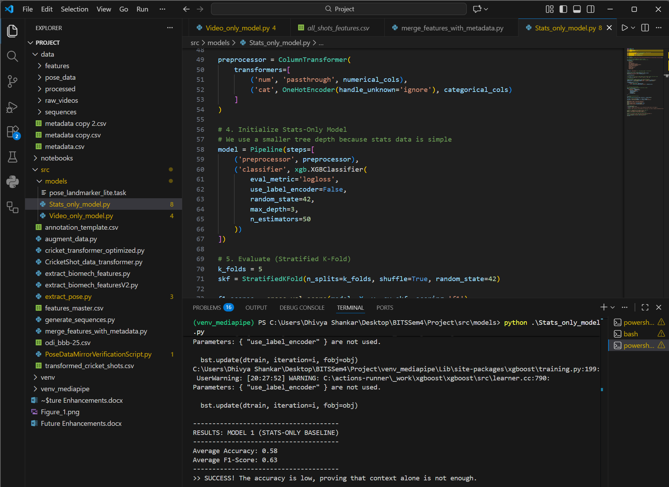
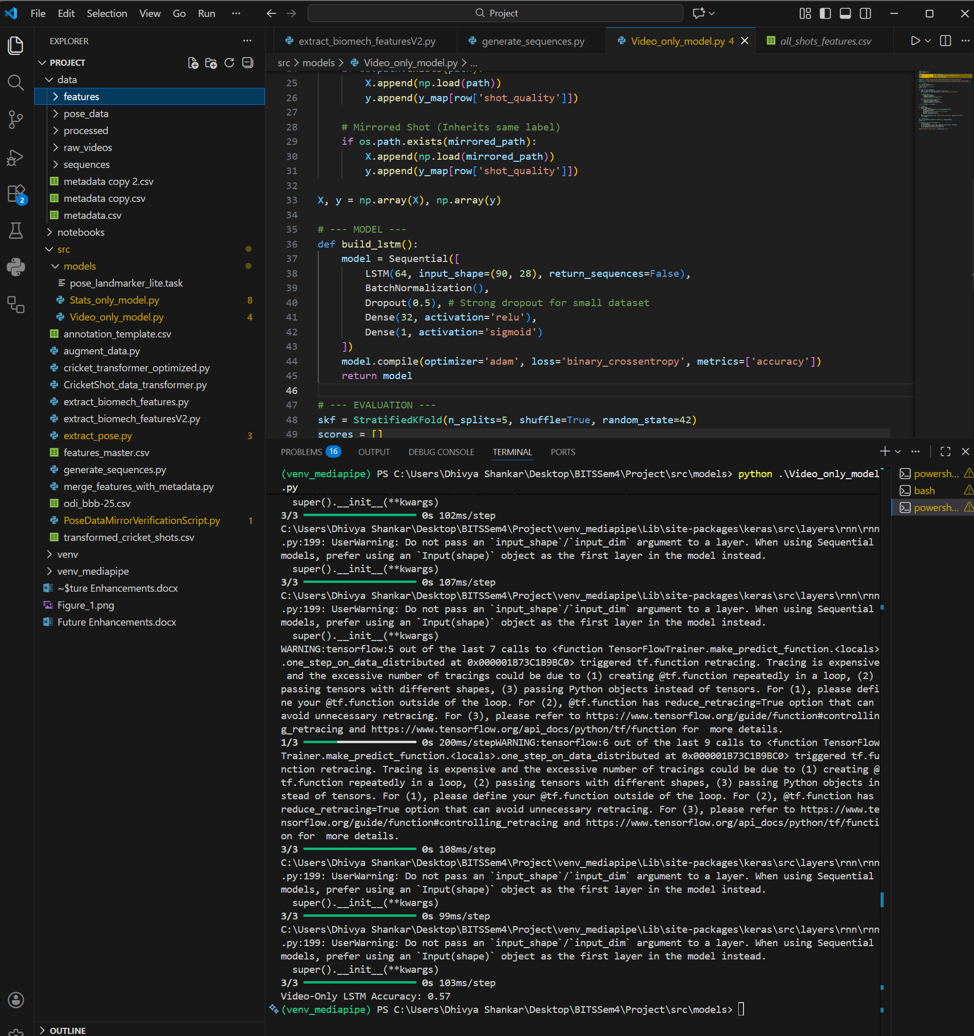

➕ ADD (High-Impact Missing Features)

Tier 1: MUST ADD (Critical for contextual blindness)
- runs_required_if_innings2 - Already have ✓
- current_score - Team's current runs (context for risk)
- run_rate - Current run rate (momentum indicator)
- required_run_rate - Only for innings 2 (pressure metric)
- ball_line - Line of delivery: leg_stump | middle | off_stump | outside_off | down_leg
- ball_length - Length: yorker | full | good_length | short | bouncer

Tier 2: SHOULD ADD (Strengthens context)
- batsman_runs - Current batsman's score (settled vs new)
- batsman_balls_faced - Balls faced by batsman (confidence)
- shot_control - Binary: 1=controlled, 0=mistimed (execution quality)
- shot_outcome - Actual outcome: 0_runs | 1_run | 2_runs | 3_runs | 4_runs | 6_runs | wicket | wide | noball

Tier 3: NICE TO ADD (If time permits)
- bowl_style - More granular: right_arm_fast | left_arm_spin | leg_spin etc.
- fielding_restrictions - Powerplay vs middle vs death (affects shot selection)

Hybrid model:
